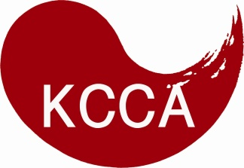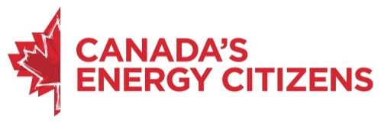

- Description
The Korean Canadian Cultural Association, as part of a sponsorship agreement with the Canadian Association of Petroleum Producers’ Canada’s Energy Citizens program, is offering three educational grants for Korean-Canadian post-secondary students: $2,500 for first place; $1,500 for second place; and $1,000 for third place. This initiative is to help Korean-Canadian students, who are in need and passionate about the positive role Canadian energy plays in our daily lives.

- Eligibility Requirements
To be eligible for the Canada’s Energy Citizens Grants, the applicant must:
- Be a Canadian Citizen or Permanent Resident.
- Be between the ages of 17 to 30.
- Provide a proof of enrolment in an accredited Canadian post-secondary institution (see Section D).
- Provide a proof of promoting Canadian energy (see Section F).
- Complete and submit this application form and required documents by August 15, 2016 (see Section G).

- Personal Information
First Name:
Last Name:
Date of Birth:
Canadian Citizen or Permanent Resident:
Phone Number:
Email Address:
Home Address:
City:
Province:
Postal Code:
- School Information
Student Number:
Name of School:
Name of Program:
Enrolment Year:

Expected Graduation Year:
*Attach a proof of enrolment when submitting this application. Acceptable proofs of enrolment are a Letter of Admission, an Official Transcript, or a Letter of Reference from an instructor or registrar.

- Need
Tell us a story about who you are, your life goals, and why you need the scholarship (250 words).

- Promotion
* Provide contact information of 20 of your friends and family members to help Canada’s Energy Citizens spread the word about the positive role Canadian energy plays in our daily lives.
First Name | Last Name | Email | Postal Code
* Visit www.EnergyCitizens.ca and www.facebook.com/CanadasEnergyCitizens to learn more about how Canadian energy is making our nation strong. Attach a proof of promoting Canadian Energy. For example, provide contact information of twenty more friends, and attach an Excel document! Share Energy Citizen’s posts on your Facebook, and Print Screen and show us how many likes you got! Create a YouTube video highlighting why you support Canadian energy, and share the link. Be creative!
- Declaration and Submission Instructions
- I declare that all the information contained in the application is true and accurate.
- I authorize the Korean Canadian Cultural Association and Canada’s Energy Citizens to use the information contained in the application for assessment, promotional and other limited purposes.
- I have obtained consent from my friends and family members to share their contact information and they understand that they may receive emails from Canada’s Energy Citizens.
By signing below, I accept the declaration above.
_________________________ _________________
Signature Date
Submit this completed application form by email at kcca2515@gmail.com. The email should contain the following attachments: a proof of enrolment and a proof of promoting Canadian energy. The deadline is 11:59PM, August 15, 2016. All inquiries should be directed to kcca2515@gmail.com.

