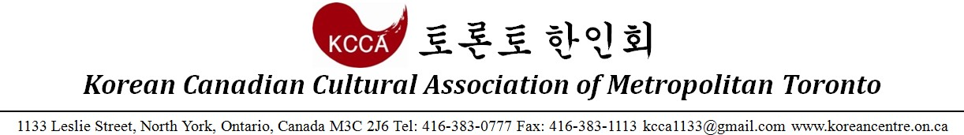

2017 Peace Run Registration Form

- I for myself, my heirs, executors, administrators, successors and assigns, HEREBY RELEASE WAIVER AND FOREVER DISCHARGE The City of Toronto, The Toronto Police Services Board, The Toronto Police Service, The Members of the Toronto Police Service Auxiliary Program, The Chief of Police, The Toronto Transit Commission, Korean Canadian Cultural Association, The Korea Times Daily and all other association, sanctioning bodies and sponsoring companies, and all their respective agents, officials and servants from claims, demands, damages, costs, expenses, actions and causes of action, whether in law or equity, in respect of death, injury, loss or damage to my person or property HOWSOEVER CAUSED rising or to arise by reason of my participation in the said event, whether as a spectator, participant, competitor or otherwise, whether prior to, during or subsequent to the event, AND NOTWITHSTANDING that same may have been contributed to, or occasioned by, the negligence of any of the aforesaid.
- I FURTHER HEREBY UNDERTAKE or HOLD AND SAVE HARMLESS and AGREE TO INDEMNIFY all of the aforesaid from and against any and all liability incurred by any or all of them as a result of, or in anyway connected with, my participation in the said event.
- BY SUBMITTING THIS ENTRY, I ACKNOWLEDGE HAVING READ, UNDERSTOOD AND AGREED TO THE ABOVE WAIVER,
RELEASE AND INDEMNITY. I WARRANT that I am physically fit to participate in this event.

Personal Information
Name |  | Sex |  | Age
Address | Street: Unit:
 | City: Province: Postal Code:
Contact Information | Home Phone:
 | Cell Phone:
 | Email:
Marathon Type
10K Run | □ $25
5K Run | □ $15
5K Walk | □ $15
10K/5K Run& 5K Walk Estimated Race Time

I DULY HEREBY APPLY FOR THE 2017 PEACE 10K RUN.

2017 (Year) (Month) (Day)

Participant: Signature:

(Under 18) Parent/Guardian: Signature:

Cheque Payable to: KCCA
Please complete and submit this form by September 15th, Friday via email to: kcca1133@gmail.com

